Gen AI Functional and Performance Testing
Test plan for generative AI features such as incident summaries and Knowledge drafting
Project: ServiceNow Incident Lifecycle Automation | Phase: Development - Performance Testing

1. Purpose and Scope
This plan covers both the functional quality and the performance of generative AI features in the incident process, for example summarising an incident, drafting resolution notes, or drafting a Knowledge article from a resolved incident.
In scope:
- Functional quality of generated text (accuracy, completeness, tone, safety)
- Response time and throughput of generation requests
- Handling of sensitive data, prompt inputs and failure cases
Out of scope:
- Selecting or training the underlying model
- Final editorial approval of Knowledge articles (done by the Knowledge manager)

2. Test Objectives
- Confirm generated summaries and drafts are faithful to the incident record and contain no invented facts.
- Confirm outputs are suitable for the audience and follow the agreed style.
- Confirm sensitive data is not exposed in outputs or logs.
- Confirm generation time stays acceptable under concurrent use.
- Confirm a human review step is always required before publishing.

3. Test Scenarios and Targets
Targets below are proposed starting points. Confirm or replace them with agreed service levels before execution.
ID | Scenario | Metric | Proposed target
GF-01 | Summarise an incident with a long work-note history | Faithfulness, completeness | No invented facts; key actions captured
GF-02 | Draft resolution notes from a resolved incident | Accuracy, usefulness | Reviewer accepts with minor edits in most cases
GF-03 | Draft a Knowledge article from an incident | Structure and correctness | Follows template; steps are reproducible
GF-04 | Input containing personal or confidential data | Data protection | Sensitive data is masked or excluded
GF-05 | Unclear, empty or very long input | Error handling | Clear message; no crash; no fabricated output
GP-01 | Single request response time | Latency | 5 seconds or less
GP-02 | Concurrent generation requests at peak | Latency, error rate | 95th percentile within 10 seconds; errors under 2%
GP-03 | Service timeout or rate limit | Fallback behaviour | User can continue manually; no data lost

4. Test Approach
- Functional: build a test set of real (anonymised) incidents and score each output against a checklist (faithful, complete, clear, safe).
- Have two reviewers score a sample to reduce individual bias, and record disagreements.
- Include adversarial inputs (misleading notes, instructions inside text) to confirm the feature does not follow them.
- Performance: run single-user baselines, then stepped concurrency, then a sustained run.

5. Tools
Tool / area | Use
Test set | Anonymised incidents with expected key facts
Scoring sheet | Checklist for faithfulness, completeness, tone, safety
Load generator | JMeter, k6 or equivalent for latency and throughput
Logging | Request logs to confirm no sensitive data is stored

6. Test Data and Environment
- Non-production instance connected to the test generative AI service.
- Anonymised data only.
- Record the model name and version used in every run.

7. Entry and Exit Criteria
Type | Criteria
Entry | Generative features configured; prompt design frozen for the test cycle; test set prepared; reviewers assigned.
Exit | Checklist pass rate meets the agreed threshold; no open high-severity safety or data issues; performance targets met; sign-off recorded.

8. Risks
Risk | Mitigation
Output varies between runs | Run each case several times and score consistency
Subjective scoring | Use a written checklist and two reviewers
Model or prompt changes mid-test | Freeze versions during a cycle and retest after changes

9. Results Log
ID | Scenario | Result | Pass / Fail | Notes

Process Diagram
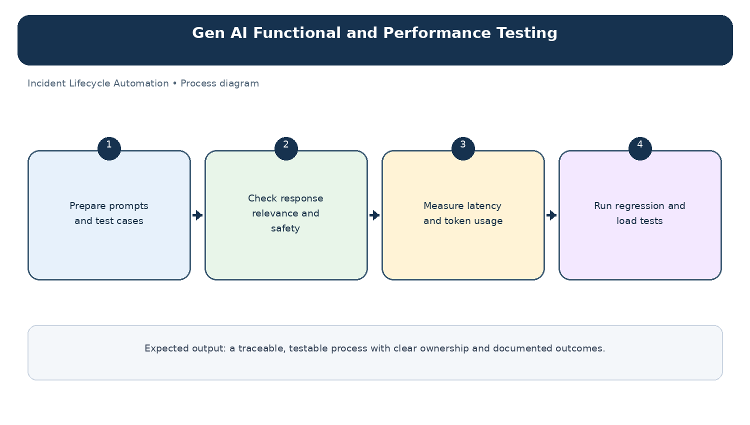
Diagram: Gen AI Functional and Performance Testing — project-specific process overview.

